

2023 International Conference on Power, Energy and Innovations
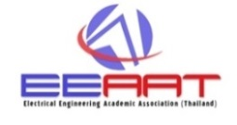




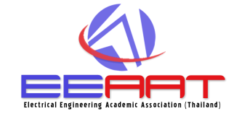

October 18-20, 2023, Hua Hin, THAILAND

SPEAKER’S BIOGRAPHY FORM

Instruction: Please type or clearly write a brief biography of the presenting author. This biography is meant to provide your session chairman with enough information to introduce you. One form is required for each paper.

Paper ID:

Paper Title:

Speaker’s name:

Affiliation:

Biography Detail

- Current Status/Position

- Education

- Research Area

